# **Seafood Pad Thai**

₨1,300 – ₨2,100

Cakes & Desserts

Take your pick from The Kingsbury’s 15 signature cakes, from simple Ribbon Cakes to chocolatey, creamy, decadent delights. There are also boxes of assorted milk, dark and white chocolates available in nine, 16 or 25 pieces. The array of desserts, too, exceeds 20 treats, with everything from Tiramisu and Apple Pie to Chocolate Mousse, Chocolate Biscuit Pudding, Trifles, Tarts and more. Ideal to share with friends or order for a special occasion.

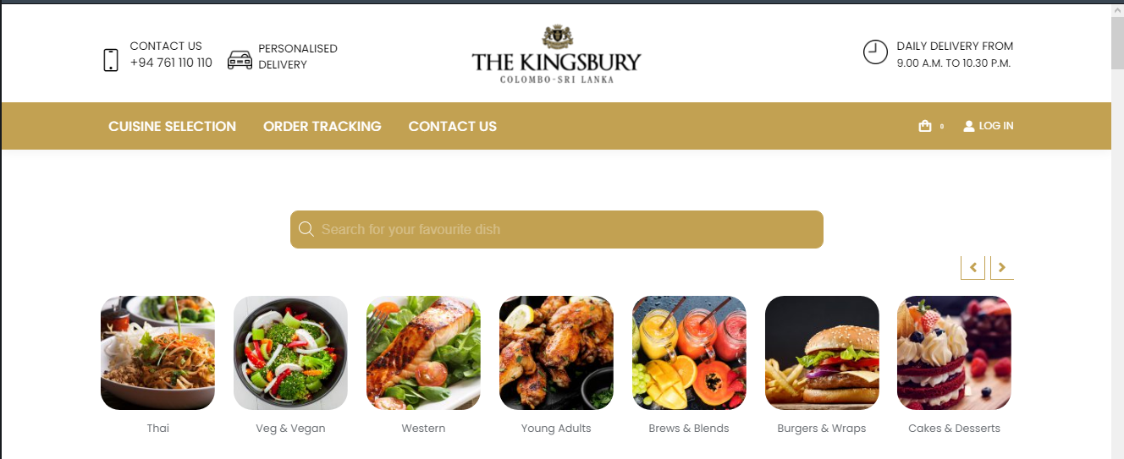

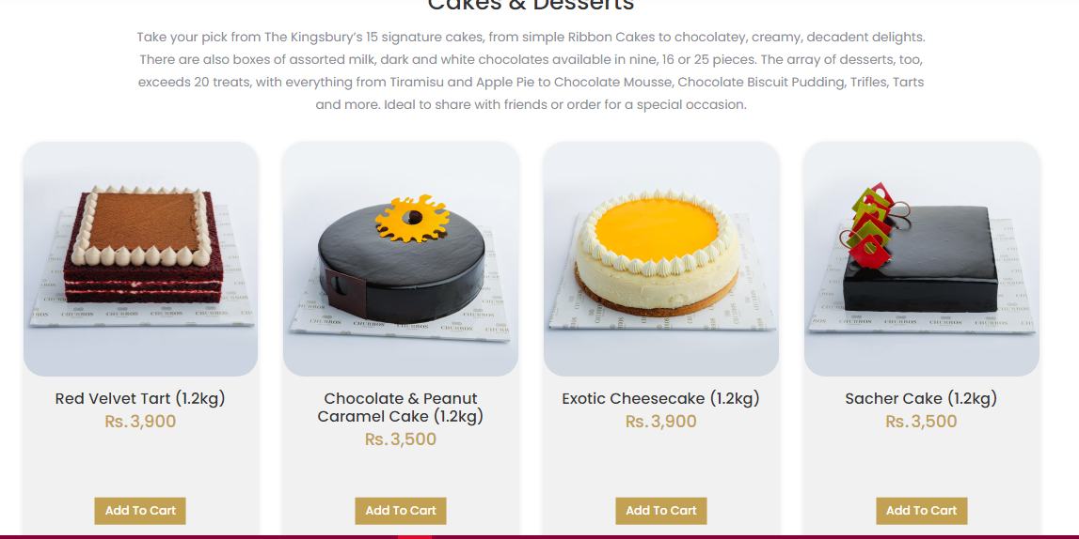

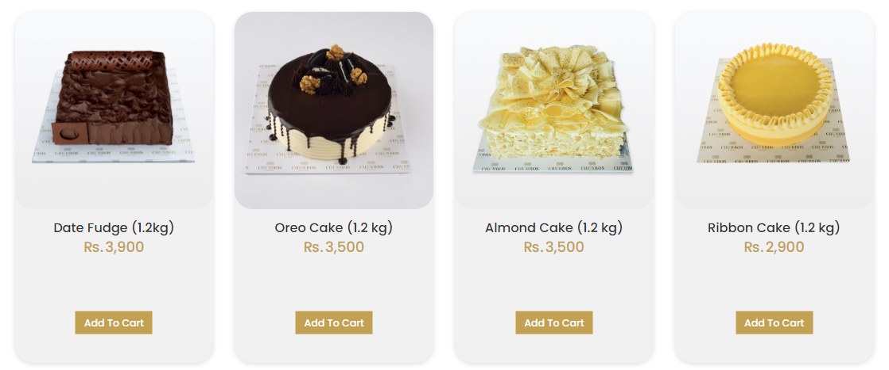

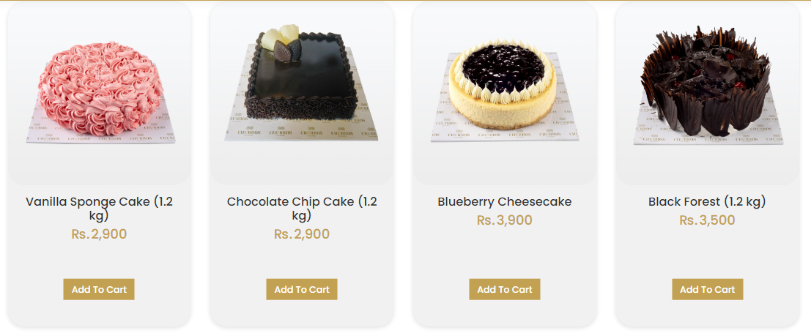

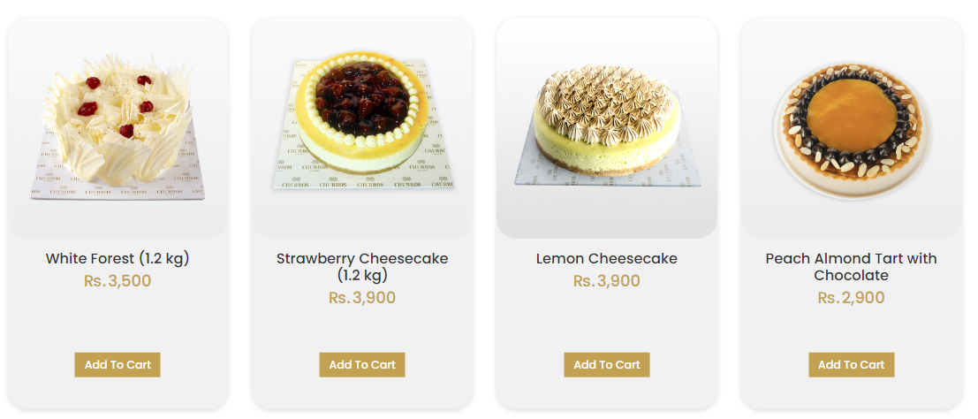

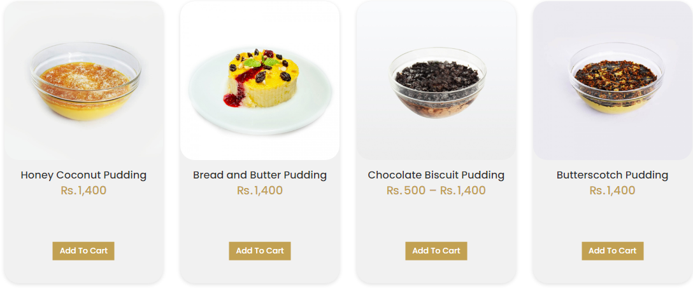

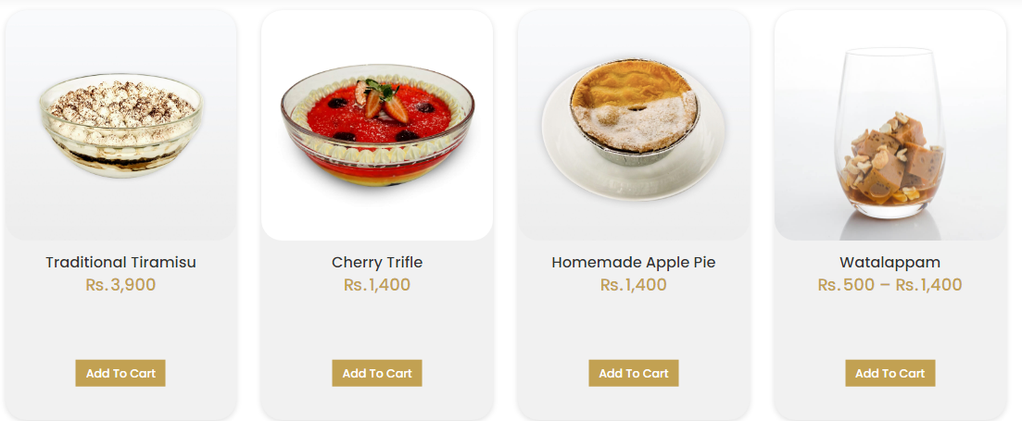

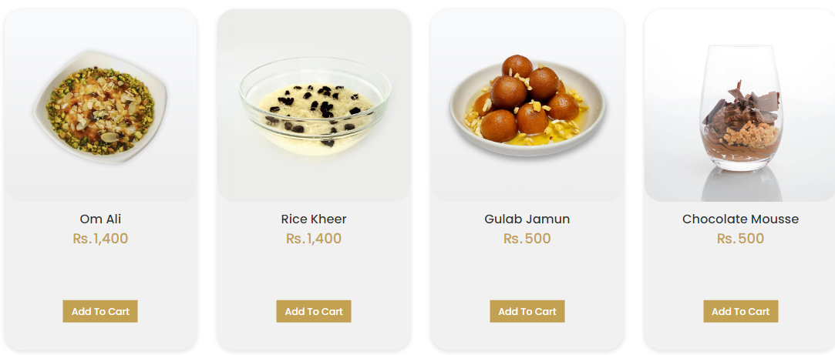

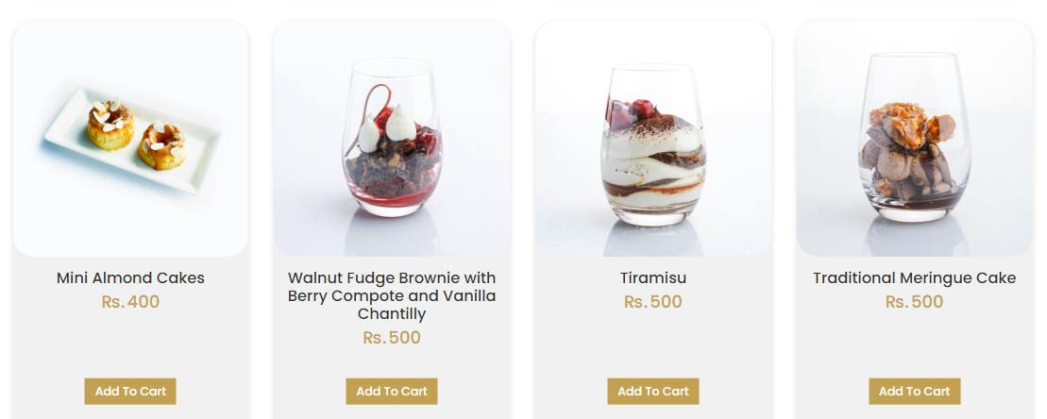

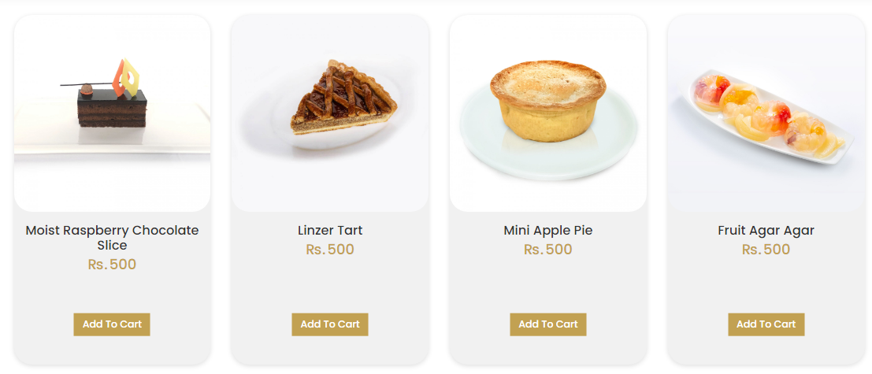

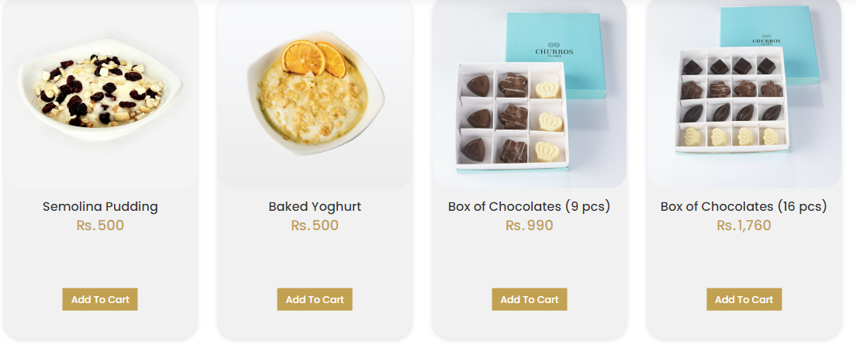



**If We click one item we are go to this page**

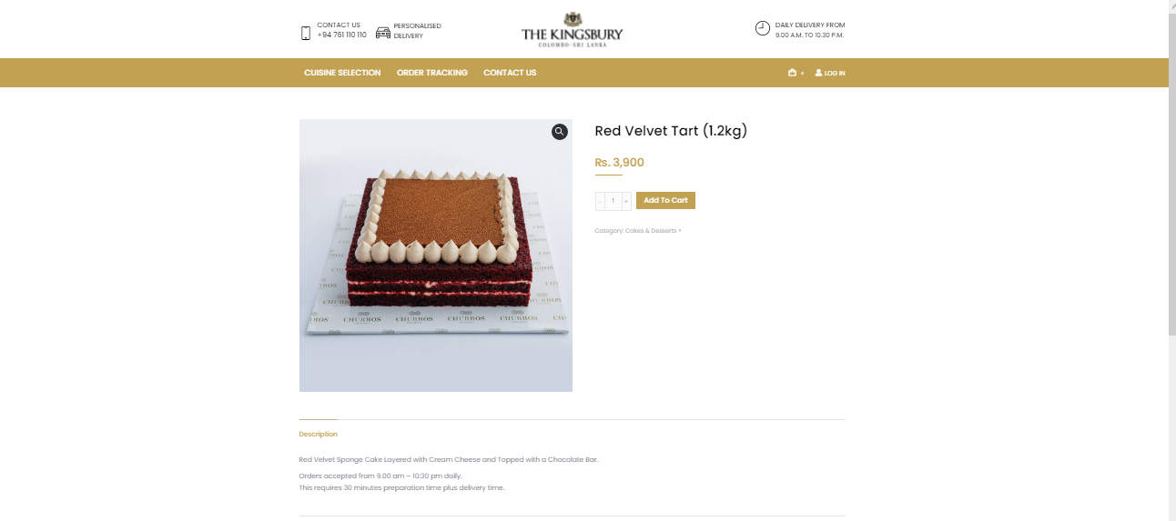

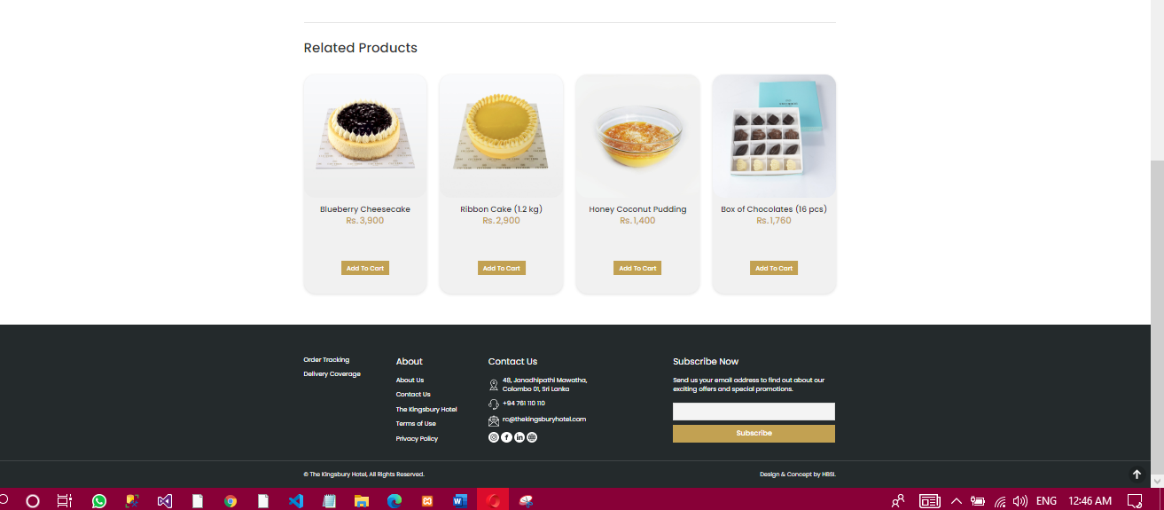

# **Red Velvet Tart (1.2kg)**

₨3,900

* [Description](https://indulgence.thekingsburyhotel.com/product/red-velvet-chocolate-bar-tart-1-2kg/#tab-description)

Red Velvet Sponge Cake Layered with Cream Cheese and Topped with a Chocolate Bar.

Orders accepted from 9.00 am – 10:30 pm daily.  
This requires 30 minutes preparation time plus delivery time.

--------------------------------------------

# **Chocolate & Peanut Caramel Cake (1.2kg)**

₨3,500

* [Description](https://indulgence.thekingsburyhotel.com/product/chocolate-peanut-caramel-cake-1-2kg/#tab-description)

Based with Cream Brule and Chocolate Mousse with Peanut Caramel and Chocolate.  
Orders accepted from 9.00 am – 10:30 pm daily.  
This requires 30 minutes preparation time plus delivery time.

===================================================================

# **Exotic Cheesecake (1.2kg)**

₨3,900

* [Description](https://indulgence.thekingsburyhotel.com/product/exotic-cheesecake-1-2kg/#tab-description)

Traditional Cheese Cake topped with Layer of Mango Agar Agar Jelly.  
Orders accepted from 9.00 am – 10:30 pm daily.  
This requires 30 minutes preparation time plus delivery time.

----------------------------------------------------------------------------------------------------------

# **Sacher Cake (1.2kg)**

₨3,500

* [Description](https://indulgence.thekingsburyhotel.com/product/sacher-cake-1-2kg/#tab-description)

Soft Chocolate Sacher Sponge Layered with Strawberry Jam and Coated with Soft Chocolate Ganache.  
Orders accepted from 9.00 am – 10:30 pm daily.  
This requires 30 minutes preparation time plus delivery time.

# **Date Fudge (1.2kg)**

₨3,900

* [Description](https://indulgence.thekingsburyhotel.com/product/date-fudge-cake-1-2kg/#tab-description)

Chocolate Cake with Dates, covered with Soft Chocolate Ganache.  
Orders accepted from 9.00 am – 10:30 pm daily.  
This requires 30 minutes preparation time plus delivery time.

# **Oreo Cake (1.2 kg)**

₨3,500

* [Description](https://indulgence.thekingsburyhotel.com/product/oreo-cake/#tab-description)

Dark Chocolate Cake Base with Cheese Frosting and Oreo Cookies covered in Chocolate Ganache.  
Orders accepted from 9.00 am – 10:30 pm daily.  
This requires 30 minutes preparation time plus delivery time.

-================================================

# **Black Forest (1.2 kg)**

₨3,500

* [Description](https://indulgence.thekingsburyhotel.com/product/black-forest-cake/#tab-description)

Chocolate Sponge Cake with Milk Chocolate Mousse, Pitted Cherries, White Cream, Dark Chocolate Curls and Snow Dust.  
Orders accepted from 9.00 am – 10:30 pm daily.  
This requires 30 minutes preparation time plus delivery time.

============================================

# **White Forest (1.2 kg)**

₨3,500

* [Description](https://indulgence.thekingsburyhotel.com/product/white-forest-cake/#tab-description)

White Vanilla Sponge Cake with Cherry Filling, Cream, White Chocolate Curls and Snow Dust.  
Orders accepted from 9.00 am – 10:30 pm daily.  
This requires 30 minutes preparation time plus delivery time.

# **Vanilla Sponge Cake (1.2 kg)**

₨2,900

* [Description](https://indulgence.thekingsburyhotel.com/product/vanilla-sponge-cake/#tab-description)

Vanilla Sponge Cake Layered with Butter Icing and garnished with Butter Icing Roses .  
Orders accepted from 9.00 am – 10:30 pm daily.  
This requires 30 minutes preparation time plus delivery time.

=====================================

# **Peach Almond Tart with Chocolate**

₨2,900

* [Description](https://indulgence.thekingsburyhotel.com/product/peach-almond-tart-with-chocolate/#tab-description)

Dark Chocolate with Almond Powder and Peach

Orders accepted from 9.00 am – 10:30 pm daily.  
This requires 30 minutes preparation time plus delivery time.